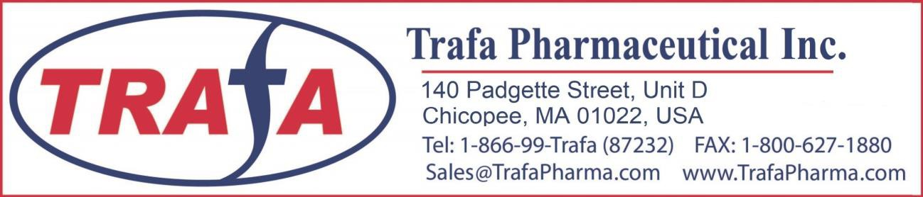

SPECIFICATION SHEET
Product Name： | Ginkgo Biloba Extract | Latin Name： | Ginkgo biloba L
Part Used： | Dried leaf | Extract Solvent： | Ethanol & water
Excipient Used： | None | Extract Ratio： | /
Representative Qty.： | 900kg

ITEM SPECIFICATION STANDARD REFERENCED

Appearance Yellow Brown powder Visual

Physical

Chemical
Odor Characteristic Sensory

Taste Characteristic Sensory
Loss on drying ≤5.0% 2g/105℃/5hrs
Ignited Ash ≤5.0% 2g/600℃/5hrs
Particle size 100% pass 80 mesh Sieve
Heavy metals ≤10ppm Atomic Absorption Arsenic(As) ≤2ppm Atomic Absorption Lead(Pb) ≤2ppm Atomic Absorption Cadmium(Cd) ≤1ppm Atomic Absorption
Mercury(Hg) ≤0.1ppm Atomic Absorption

Ginkgolic Acid ≤10ppm CP05

Total flavone glycosides ≥24.0% HPLC

Quercetin CP05

Kaempferol CP05

Assay

Isorhamnetin CP05

GinkgolidesA CP05

GinkgolidesB CP05

GinkgolidesC CP05

Bilobalides CP05

Total microbacterial count ≤1000CFU/g CP05

Microbial

Yeast &Mould ≤100CFU/g CP05

Escherichia Coli presence Negative CP05

Salmonella Negative CP05

Else | Packing | Pack in paper-drums and two food grade poly bags inside. Net weight: 25kg/drum
Else | Storage condition | Store in a well closed place with constant low temperature and no direct sun light

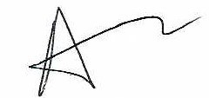Note: The above information is based on the certificate of analysis received from the manufacturer of this product and not intended

________________
as a substitute for strict quality control analysis by the purchaser Reviewed by :
of this product. Abdullah Malik (QA)

